Master Project Document: Air Pollution–Weather Coupled Forecasting System (Delhi NCR Focus)

1. Problem Statement
The challenge is to develop a high-resolution, coupled air-quality forecasting system specifically tailored to the Delhi NCR region. Traditional AQI forecasts treat meteorology and pollutant dispersion separately, but Delhi’s severe pollution episodes are driven by feedback loops (e.g. inversion layers trapping PM2.5 and aerosols affecting local weather). The goal is a 72-hour AQI outlook that dynamically interlinks meteorology (temperature, wind, PBL height) with key pollutants (PM2.5, PM10, O₃, NOₓ). The solution must use advanced weather-chemistry models (like WRF-Chem or similar) with two-way coupling, explicitly modeling atmospheric inversions and stubble-burning plumes, and present results on a real-time dashboard.

2. Problem Understanding & Interpretation
- Focus Area: Delhi NCR – a densely populated megacity with extreme winter pollution spikes.
- Forecast Horizon: 72 hours ahead AQI predictions for PM₂.₅, PM₁₀, and ground-level O₃/NOₓ across Delhi and surrounding areas.
- Key Requirements: Two-way coupling between weather and chemistry – e.g. model how high PM from stubble burning affects local temperature/PBL, and vice versa. The system should monitor inversion strength and forecast dispersion of regional smoke plumes.
- User Audience: MoES and local authorities require actionable forecasts to trigger mitigation (GRAP) measures, and the public benefits from health advisories. Unlike consumer apps, this is an official tool (potentially offline) tailored to policy needs.

3. Background Research
Delhi’s winter air is notorious for hazardous pollution. Studies confirm PM₂.₅ dominates Delhi’s pollution peaks and routinely exceeds national safety limits. In late October–November each year, intense stubble-burning in Punjab/Haryana injects large smoke plumes. Under calm, cold winter conditions, these pollutants accumulate. For example, Delhi’s 24-hr PM₂.₅ has reached ~500 µg/m³ during peak stubble season. The region’s meteorology exacerbates the problem: long nights and low sun angles produce strong surface inversions that trap cold, polluted air. Inversions act like a lid preventing dispersion of PM and aerosols.
Analysis of recent years’ data shows Delhi’s air quality worsens sharply from late October through mid-November, coinciding with biomass burning and Diwali festivities. These regional emissions, carried by prevailing winds, pile up under weak winds and stable layers. In summary, Delhi’s air pollution is driven by seasonal meteorology and regional sources – a coupled system that demands an integrated modeling approach.

4. Existing Solutions / Current System
Current forecasting tools include:
- CAMS (Copernicus Atmosphere Monitoring Service): A European system that merges global chemical transport models with satellite data to provide daily pollutant forecasts worldwide. Its coarse global output is used as input for downstream services.
- SAFAR (India): IITM’s “System of Air Quality and Weather Forecasting And Research” provides 3-day forecasts for Delhi and other Indian cities (combining models and measurements). It is India’s early-warning AQI system (for example during events like CWG-2010) and runs under MoES.
- MoES / NCAP WRF-Chem System: The Indian government has already begun developing high-resolution local forecasts. IITM/IMD’s recent prototype uses WRF-Chem at 400 m grid for Delhi, assimilating satellite AOD and surface data to improve PM₂.₅ forecasts. This system is a first-of-its-kind chemical weather model for the NCR.
- Commercial Apps: Global and consumer products (e.g. BreezoMeter, IQAir) use a mix of models, ground sensors, and crowd-sourced data. However, they lack the specific offline, two-way coupled capability requested by MoES and are less transparent for policy use.
Despite these efforts, no existing system fully meets the SIH requirements: none explicitly simulates two-way meteorology-chemistry feedback for Delhi’s inversions and stubble events, nor provides a dedicated official dashboard.

5. Literature & Market Research
Academic and industry research highlights the state of the art. High-resolution modeling (sub-km scales) is shown to greatly improve urban PM forecasts. WRF-Chem is widely used for coupled simulations of pollution events (forest fires, urban smog) worldwide. For instance, studies of Indonesian haze and Chinese winter smog demonstrate how WRF-Chem with fire inventories (FINN) can simulate smoke dispersion. In India, Raj et al. (2021) and Jena et al. (2021) (Sci. Rep.) emphasize that coupled models and data assimilation are essential to capture Delhi’s severe episodes Market solutions like CAMS’s AIR-Portal also underline the trend towards combining regional/global models with local data for high-res urban forecasts.
On the data-assimilation front, incorporating satellite AOD and dense ground sensors is shown to reduce PM₂.₅ forecast errors by up to ~50%. The literature also notes the positive aerosol–radiation feedback in similar contexts: high PM loads reduce PBL height, further trapping pollutants (e.g. studies of Beijing/Morning haze). In summary, research supports our approach of integrated WRF-Chem modeling with data assimilation and inversion-aware corrections to advance Delhi air-quality forecasting.

6. Gap Identification
Key gaps in current approaches are:
- Lack of True Two-Way Coupling: Most operational forecasts treat meteorology and chemistry sequentially. They do not simulate how peak pollution itself (e.g. dense PM₂.₅) alters local temperature profiles and stability. As the SIH problem notes, ignoring these feedbacks causes “significant inaccuracies”.
- Insufficient Resolution: Existing forecasts (even CAMS or early WRF efforts) are often at ~1–10 km scales. Delhi’s complex urban and valley terrain demands much finer grids (~0.5–1 km) to resolve hotspots and boundary-layer variations.
- Inversion Tracking: No current consumer model explicitly outputs inversion strength or forecasts the onset/breakup of the inversion layer, a critical factor in Delhi’s smog.
- Source Attribution: While SAFAR and others mention stubble as a cause, they lack detailed plume modeling. The proposed system must explicitly track farm-fire emissions and their dispersion under prevailing winds.
- User Focus: Consumer apps serve individuals. For policymakers, there is no tailored, language-localized, offline-capable dashboard integrating official data. In short, Delhi’s authorities need a dedicated tool built to their needs – offline and on official data – which is not provided by generic systems.

7. Proposed Solution
We propose an operational pipeline combining numerical modeling, data assimilation, and visualization:
- Data Ingestion: Collect meteorological data (GFS/IMD), emissions inventories (industrial, vehicular, biomass burn from satellites/fire-hotspots), satellite AOD (MODIS/VIRTA), and ground AQ sensors (CPCB/SAFAR).
- WRF-Chem Modeling: Configure WRF-Chem for the NCR domain (nested grids down to ~1 km). Include chemistry modules for PM₂.₅, PM₁₀, O₃, NOₓ. Implement two-way coupling so that aerosol concentrations influence radiation and PBL evolution.
- Atmospheric Inversion Module: Integrate a subroutine to detect inversion layers (based on temperature lapse profiles). This module will quantify inversion strength (e.g. temperature jump) and feed it back into the PBL parameterization. It will also adjust dispersion rates accordingly.
- Stubble-Burning Forecast: Use satellite fire detections and historical patterns to inject biomass-burning emissions into WRF-Chem in real time. Model how these plumes rise (or get trapped by inversions) and spread.
- Data Assimilation: Apply routine assimilation of satellite AOD and surface PM₂.₅ observations (e.g. via an EnKF or variational scheme) to correct model initial conditions. This reduces forecast bias by ~50%.
- Output Products: Generate gridded 72-h forecasts of PM₂.₅, PM₁₀, O₃, and derived AQI. Also output ancillary variables: PBL height, inversion index, wind fields, and a “stubble plume dispersion map.”
- Dashboard & Alerts: Build a user-friendly web portal (and mobile app) that displays the high-resolution forecasts on a map of Delhi NCR. Include layers for AQI categories, pollutant concentration contours, inversion strength, and plume trajectories. Provide localized forecasts (zone-by-zone) and summary charts. Enable automated alerts (e.g. SMS/email) when forecasts cross hazardous thresholds.
This design directly follows the SIH directive to “dynamically interlink meteorology with pollution dispersion” and to “explicitly track atmospheric inversion strength”.

8. Innovation / Novelty
Our solution’s novel features include:
- Fully Coupled Local Model: Unlike existing tools, this is a dedicated Delhi-NCR forecasting system with real two-way meteorology–chemistry coupling. It explicitly models how heavy aerosol loads suppress boundary-layer mixing, in line with recent research on aerosol–PBL feedback.
- Stubble Plume Simulation: We uniquely incorporate real-time biomass burning data to simulate smoke plume injection and transport under current weather conditions. This goes beyond mere flagging of burn events.
- Inversion-Focused Forecasting: The system continuously quantifies inversion layers and adjusts mixing heights. No prior Delhi forecast explicitly outputs inversion metrics as we propose.
- Ultra-High Resolution: By targeting sub-kilometer grids (e.g. 500 m), we resolve local hotspots and terrain effects. This “neighborhood-scale” forecasting (as envisioned by IITM/NCAR) is cutting-edge.
- Decision-Maker Dashboard: A live, bilingual dashboard designed for officials – combining all information (pollutants, forecasts, inversion strength) in one place. It can run offline if needed on a local intranet. This integration of forecast, visualization, and alerts is a step-change over raw data feeds or static reports.
In summary, our approach turns state-of-the-art climate and chemical modeling into a tailored decision-support tool for Delhi, filling gaps identified by experts.

9. Technical Architecture
The system architecture consists of the following components:
- Data Layer: Sources include IMD/GFS meteorological fields, MODIS satellite AOD, CPCB air quality stations, SAFAR sensors, and fire hotspots (e.g. VIIRS). A pre-processing module ingests and formats these (into NetCDF or similar).
- Model Core: A Linux HPC cluster runs WRF-Chem. The workflow: (1) WRF Preprocessing (metgrid), (2) WRF-Chem simulation of 72 h, (3) Chemistry post-processing. The model is configured with nested domains (e.g. 9 km → 3 km → 1 km). Emissions pre-processor (e.g. SMOKE or in-built) generates chemical inputs including dynamic fire emissions.
- Assimilation Engine: A Python/Fortran module implements data assimilation (e.g. 3DVar or EnKF), blending observations into WRF initial/boundary conditions. This runs between forecasting cycles (daily).
- Analytics & Storage: Results (gridded forecasts, key parameters) are stored in a database (e.g. PostGIS or object store). An “inversion index” time series is computed and archived.
- Visualization Layer: A web server (e.g. Python Flask/Node.js) retrieves forecast data and renders interactive maps. The frontend (JavaScript, Leaflet/D3.js) shows pollutant contours, AQI color zones, PBL heights, etc. Alerts (via email/SMS API) are triggered when forecast AQI > thresholds.
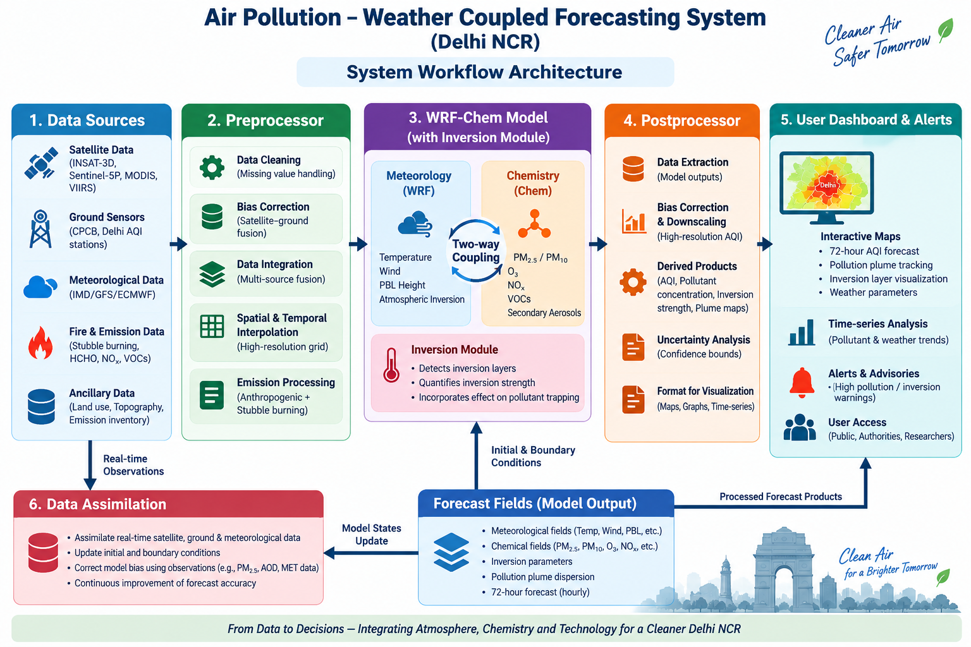

10. Technology Stack
- Modeling: WRF-Chem (Fortran-based) on Linux.
- Data Processing: Python (NumPy, xarray, netCDF4), GIS libraries (GDAL), and possibly R for analysis.
- Web & Database: PostgreSQL/PostGIS for spatial data; Django or Flask for backend; React or Vue.js for frontend mapping.
- ML Components: TensorFlow/PyTorch (if using ML for bias-correction or inversion detection).
- DevOps: Git for version control; Docker or Conda for reproducible environments; Linux shell scripting/cron for scheduling daily runs.

11. Hardware/Software Requirements
- HPC / Servers: A compute cluster (e.g. 100+ CPU cores, 512+ GB RAM) to run the coupled model at high resolution within the required timeframe. GPUs (e.g. NVIDIA) if using deep learning modules. A database server (8 cores, 32 GB RAM) for storing results.
- Storage: Several TB of disk for model grids, input/output data, and archives (forecast data, observations).
- Networking: Reliable internet access for data ingestion (satellites, weather feeds) and, if required, for dashboard hosting.
- Software: Linux OS (e.g. CentOS/Ubuntu), WRF-Chem compiled with necessary physics/chemistry options, Python environment with scientific libraries, PostgreSQL, Node.js/Apache for web service.
- Sensors (optional): Additional low-cost air quality monitors could be deployed for supplemental data, though existing SAFAR/CPCB networks cover Delhi well.

12. Implementation Plan
- Phase 1 – Setup (Months 1–3): Assemble the team and resources. Acquire meteorological and emissions data. Install WRF-Chem and preprocessors. Develop inversion detection module.
- Phase 2 – Model Calibration (Months 4–6): Configure WRF-Chem for NCR region. Run baseline simulations for past pollution events. Tune physical/chemical parameters (e.g. boundary-layer schemes, emission rates) using historical data.
- Phase 3 – Assimilation & Integration (Months 7–9): Implement data assimilation of AOD/PM₂.₅. Integrate inversion module and fire emissions. Conduct intensive testing against 2025–26 haze episodes.
- Phase 4 – Dashboard Development (Months 9–11): Build the web interface. Connect front-end to the model output database. Implement alerting system.
- Phase 5 – Testing & Validation (Months 11–12): Run 3-month trials in parallel with existing forecasts (SAFAR/CAMS) for validation. Gather stakeholder feedback, refine UI.
- Phase 6 – Deployment & Training (Month 13 onward): Deploy the system for MoES/Delhi agencies. Provide training to operators. Establish maintenance and update schedule.

13. Feasibility Analysis
- Data Availability: India has robust meteorological and emissions data (IMD, CPCB/SAFAR). Satellite AOD is freely available. Fire hotspots (VIIRS) provide timely stubble info. Thus input data is plentiful.
- Technical Capability: WRF-Chem is open-source and well-documented. Indian agencies (IITM/IMD) already have expertise (e.g. 400 m model). Collaboration with MoES institutes can leverage this experience.
- Computational Resources: Required compute (hundreds of cores) is significant but attainable via government HPC or cloud credits. The timeline allows building scripts for automated running.
- Budget/Schedule: As a software-centric project, costs are mainly personnel and compute (lower than, say, building new sensors). The 12–18 month plan is realistic for a prototype, given prior similar projects.
- Risks: Most risks are technical – model biases, assimilation complexity, and achieving fast runtimes. These are mitigated by starting with established WRF setups and by incremental testing. The feasibility is high, as MoES’s existing efforts demonstrate.

14. Advantages
- Accurate, Timely Forecasts: By capturing local dynamics, forecasts will be more reliable, especially during acute haze events. Prior work shows such high-res WRF forecasts “help decision-makers in Delhi make informed decisions”.
- Health & Policy Impact: Early warnings let authorities trigger GRAP actions (schools closed, traffic curbs). Improved forecasts can reduce pollution exposure and related health costs.
- Resource Optimization: A regional, offline system ensures resilience (no dependence on foreign services). It can also use local language and integrate official datasets.
- Innovation Leadership: The project would position India at the forefront of urban air-quality modeling (a world-first operational 400m-coupled forecast was already developed).
- Future Integration: The framework can be extended to include other hazards (heat stress forecasts, etc.), leveraging the same infrastructure.

15. Limitations & Risks
- Computational Load: WRF-Chem at ~1 km requires heavy CPU/GPU usage. Real-time, daily 72-h forecasts are demanding; delays in computation could reduce timeliness.
- Emission Uncertainty: Inaccurate or coarse emission inventories (especially for small sources or open fires) can bias results. Continuous updating of emissions data is needed.
- Data Gaps: Satellite retrievals can be missing (cloud cover) or biased. If too few ground stations report in real time, assimilation quality suffers.
- Complexity: Maintaining such a coupled system needs specialized expertise (meteorology, chemistry, software). Staff turnover or lack of training is a risk.
- User Adoption: A new dashboard must be embraced by authorities; if it’s not user-friendly or trusted, its impact is limited. Regular engagement with stakeholders is necessary.

16. Future Scope
Beyond the initial deployment, the project can grow to include:
- Expanded Coverage: Scale the domain to cover all of Northern India (Indo-Gangetic Plain) or other megacities (e.g. Kolkata, Mumbai) with similar high-resolution forecasts.
- Additional Pollutants: Incorporate forecasts for NO₂, SO₂, CO, and ultrafine particles.
- Machine Learning Enhancements: Add hybrid ML post-processing to correct model biases or to learn fine-grained patterns from sensor networks.
- Public Awareness Tools: Develop citizen-focused apps or integrate with national services (e.g. Disaster Management) for broader dissemination.
- Climate Integration: Link the AQ forecast system with seasonal climate outlooks to forecast multi-week pollution trends.

17. References/Sources
- MoES SIH Problem Statement “Air Pollution–Weather Coupled Forecasting System (Delhi NCR Focus)”(2026).
- Encyclopedia of the Environment: Inversion layer, fog and other curiosities of the lower atmosphere (Fig.1, inversion trap effect).
- Centre for Research on Energy and Clean Air (2022), “Delhi’s air quality and stubble burning trends”.
- Jena et al. (2021), Sci. Reports: “Performance of high-resolution (400 m) PM₂. ₅ forecast over Delhi”.
- Copernicus Atmosphere Monitoring Service – Air Quality (CAMS) overview.

